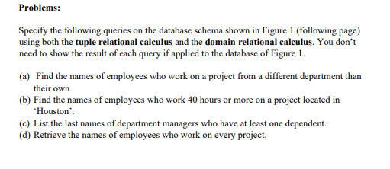
1a. Tuple Relational Calculus:
{e.FNAME,e.LNAME | EMPLOYEE € AND ((((∃p)( ∃w)(PROJECT(p) AND WORKS_ON(w) e.DNO ≠ p.DNUM AND e.SSN = w.ESSN AND w.PNO = p.PNUMBER))}

1a. Domain Relational Calculus:
{qs| (∃t)( ∃z) (EMPLOYEE(qrstuvwxyz) AND (∃a)( ∃b)(WORKS_ON(abc) AND (∃e)( ∃g)(PROJECT(defg) AND t = a AND b = e AND g ≠ n)))}

1b.Tuple Relational Calculus:
(e.FNAME,e.LNAME | EMPLOYEE(e) AND ((∃p)( ∃w) (PROJECT(p) AND (WORKS_ON(w)w.HOURS >= 40 AND p.PLOCATION = ‘Houston’ AND e.SSN=w.ESSN AND w.PNO = p.PNUMBER)))}

1b.Domain Relational Calculus:
{ qs | (∃t) EMPLOYEE(qrstuvwxyz) AND (∃ a)( ∃ b)( ∃ c) WORKS_ON(abc) AND (∃e) (∃f) Project(defg) AND t = a AND b = e AND c >=40 AND f = “Houston”)))}

1c. Tuple Relational Calculus:
{e.LNAME | EMPLOYEE (e) AND ((∃d)(DEPENDENT(d) AND e.SUPERSSN = d.ESSN ))}
1c. Domain Relational Calculus:
{s | (∃y) (EMPLOYEE(qrstuvwxyz) AND (∃a) (DEPENDENT(abcde) AND y = a)}

1d. Tuple Relational Calculus:
(e.FNAME, e.LNAME| EMPLOYEE(e) AND (∀p) (NOT(PROJECT(p)) OR (∃w) (WORKS_ON(w) AND p.PNUMBER = w.PNO
AND w.ESSN=e.SSN))}

1d. Domain Relational Calculus:
(qs |(∃t) (EMPLOYEE(qrstuvwxyz) AND (∀b) (NOT(PROJECT(abcd)) OR (∃e) (∃f)(WORKS_ON(efg) AND e=t AND f=b)) }

